**PROGRAM TITLE-6**

**VACCUM CLEANER**

**AIM:**

To write and execute the python program for vaccum cleaner.

**PROCEDURE:**

1. **Initialize:**
   * Start the vacuum cleaner.
   * Position the vacuum cleaner at the starting point in the room.
2. **Scan Environment:**
   * Use sensors (such as infrared, ultrasonic, or cameras) to detect obstacles and map the environment.
   * Determine the boundaries of the cleaning area.
3. **Movement:**
   * Move forward until an obstacle is detected.
   * When an obstacle is detected, decide whether to turn left, right, or perform another action based on a predefined algorithm or random choice.
   * Continue moving and adjusting direction until the entire cleaning area is covered.
4. **Cleaning:**
   * Activate the vacuum mechanism while moving to pick up dirt and debris.
   * Adjust cleaning intensity or speed based on the surface being cleaned (e.g., carpet, hardwood floor).
   * Use brushes or other mechanisms to agitate dirt and ensure thorough cleaning.
5. **Obstacle Handling:**
   * Detect and navigate around obstacles such as furniture, walls, and other objects in the environment.
   * Avoid collisions and navigate around objects to prevent damage to the vacuum cleaner and surrounding items.
6. **Edge Detection:**
   * Detect edges and corners of the cleaning area to ensure complete coverage.
   * Use specialized algorithms to ensure thorough cleaning along edges and corners.
7. **Battery Management:**
   * Monitor battery levels and return to the charging station when the battery is low.
   * Resume cleaning from the last location after recharging if the cleaning process is not completed.
8. **Completion:**
   * Stop the vacuum cleaner once the entire cleaning area has been covered.
   * Indicate completion through visual or auditory signals.

**CODING:**

import random

def display(room):

print(room)

room = [

[1, 1, 1, 1],

[1, 1, 1, 1],

[1, 1, 1, 1],

[1, 1, 1, 1],

]

print("All the rooom are dirty")

display(room)

x =0

y= 0

while x < 4:

while y < 4:

room[x][y] = random.choice([0,1])

y+=1

x+=1

y=0

print("Before cleaning the room I detect all of these random dirts")

display(room)

x =0

y= 0

z=0

while x < 4:

while y < 4:

if room[x][y] == 1:

print("Vaccum in this location now,",x, y)

room[x][y] = 0

print("cleaned", x, y)

z+=1

y+=1

x+=1

y=0

pro= (100-((z/16)*100))

print("Room is clean now, Thanks for using : 3710933")

display(room)

print('performance=',pro,'%')

**OUTPUT:**

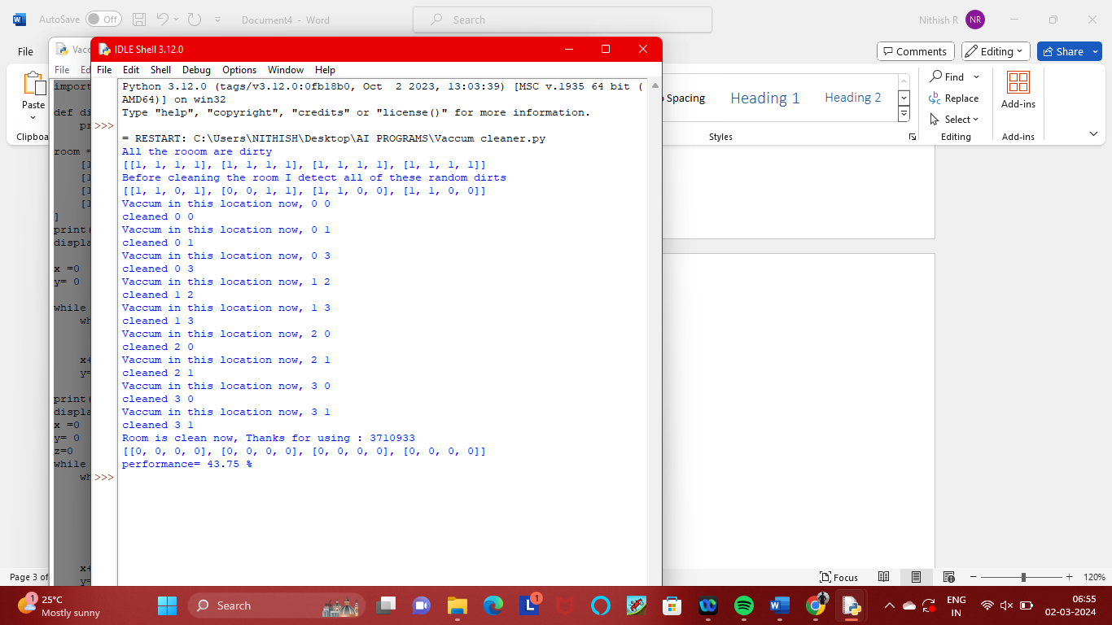

**RESULT:**

Thus the result has been successfully executed and verified.